18.1.4 Editors - Drivers Editor - Channel Menu
Dopesheet Editor - Channel Menu 2
Channel Menu - Dopesheet + Action Editor mode 2
Delete Channels 2
Delete Invalid Drivers 2
Group Channels 2
Ungroup Channels 2
Channel Settings 2
Last Operator Toggle Channel Settings 3
Type 3
Toggle Channel Editability 3
Last Operator Toggle Channel Editability 3
Type 3
Extrapolation Mode 3
Constant Extrapolation 3
Linear Extrapolation 3
Make Cyclic 3
Clear Cyclic 3
Last Operator Set Keyframe Interpolation 3
Type 3
Reveal Curves 3
Last Operator Reveal Curves 3
Select 3
Hide selected Curves 4
Hide unselected curves 4
Last Operator Hide Curves 4
Unselected 4
Expand Channels 4
Last Operator Expand Channels 4
All 4
Collapse Channels 4
Last Operator Collapse Channels 4
All 4
Move 4
Last Operator Move Channels 4
Direction 4
Revive Disabled F-Curves 4

Dopesheet Editor - Channel Menu

This menu contains functionality to manage the channels in the channels list at the left.

The menu doesn't exist in all modes. It exists in Dopesheet, Action Editor and Grease Pencil mode. And has different content.

Channel Menu - Dopesheet + Action Editor mode

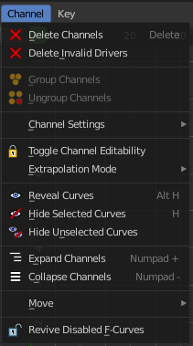
Delete Channels
Deletes the selected channels and all its keyframes.

Delete Invalid Drivers
Deletes invalid drivers.

Group Channels
Creates a custom group from the selected channels.
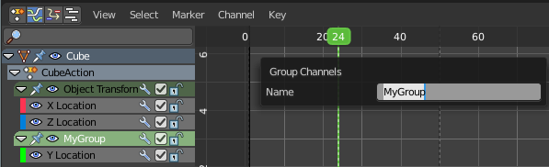

Ungroup Channels
Removes the selected channels from the group, and adds them back to the original hierarchy.

Channel Settings
Adjust the locks and checkboxes in the channels list from outside of the channels list for all selected elements at once. With Toggle Mute you could for example disable all selected channels at once.
The menu items should be self explaining.
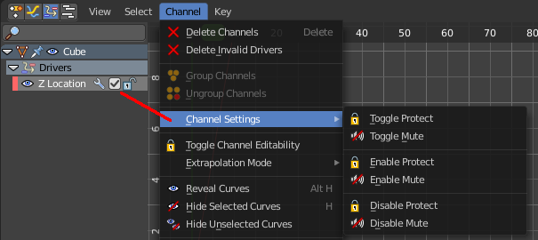

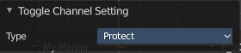
Last Operator Toggle Channel Settings

Type
The type to toggle.

Toggle Channel Editability
Toggles the locks in the channel list from their previous state to locked and back.

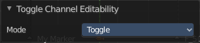
Last Operator Toggle Channel Editability

Type
The type to toggle.

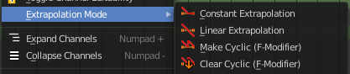
Extrapolation Mode
Sets the extrapolation mode for the selected F-Curves. Means how the curve acts at the beginning and the end of the F-Curve.

Constant Extrapolation
The animation curve continues straight at the end.

Linear Extrapolation
The animation curve continues the last direction.

Make Cyclic
Makes the animation loopable. The interpolation curves are adjusted so that the first frame fits to the last frame.

Clear Cyclic
Removes the cyclic extrapolation.

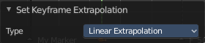
Last Operator Set Keyframe Interpolation

Type
Set the extrapolation mode for the selected F-Curves.

Reveal Curves
Reveals all hidden curves.

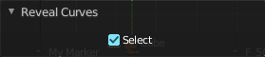
Last Operator Reveal Curves

Select
Select all revealed curves.

Hide selected Curves
Hides the selected curves.

Hide unselected curves
Hides the unselected curves.

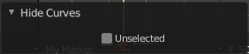
Last Operator Hide Curves

Unselected
Hide the unselected or selected curves.

Expand Channels
Expands all channels in the channel list.

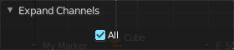
Last Operator Expand Channels

All
Expand all Channels, or just the selected channels.

Collapse Channels
Collapses all channels in the channels list.

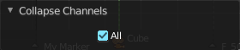
Last Operator Collapse Channels

All
Collapse all Channels, or just the selected channels.

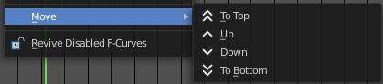
Move
Sort the items in the channels list.

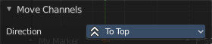
Last Operator Move Channels

Direction
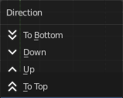
Sort the items in the channels list.

Revive Disabled F-Curves
Clears the disabled tag from all f-curves to get broken F-Curves working again.

